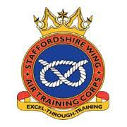

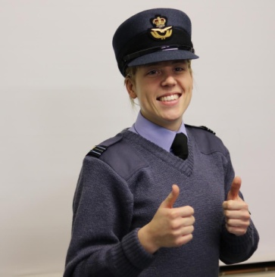
OC’S BLOG:
Breaking news:
The Squadron raised £5,821.99 with the Royal British Legion at Morrisons for the Poppy Appeal. This charity supports the Armed Forces community, past and present. rbl.org.uk

Flight Lieutenant Laura Horobin says:
Welcome to 425 Squadrons newsletter. Something we have recently introduced into the unit to help keep everyone updated on our current events and recognise the success of our excellent cadets. Starting off the new year in style, becoming a bit more up to date! We aim to develop our social media platforms; 425 (Aldridge) Squadron Facebook (private), 425 (Aldridge) Squadron Facebook (public), Best of Walsall Platform, Twitter and Instagram. We have issued a letter to gain parental/ guardian consent if you can return the slip on the bottom asap that would be greatly appreciated. Not on Facebook? Please join us, this is our main form of communication, letters are so last year and pigeons take far too long! To increase our communication I would like to collaborate a list of all parent/ guardian emails, to, where possible email out information with attachments. The cadets and staff at 425 work hard to provide the best Air Cadet experience for your children and I believe their success should be advertised, along with
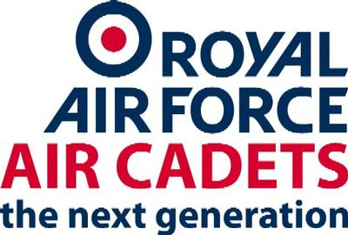
425 Air Cadets
‘The future lies above and the challenge lies within.’

their involvement in the local community. I am always proud of the great efforts the cadets go to, commitment they show and the successes they achieve. So lets show it! If you ever have any questions or need to get in touch my email is oc.425@aircadets.org and contact 07968033021 (there is also a copy of this in your son/daughters 3822). Here's to a fantastic 2020.
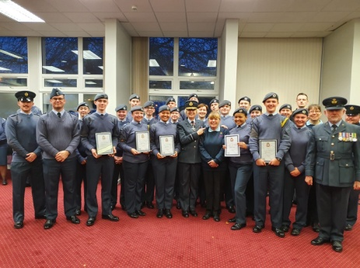
THE BAND
On the 17th November 2019, CWO Keely Mansell, SGT Ben Smith, SGT Kyra Holden, CPL Nathan Blakemore and CDT Sam Kitchen from 425 Aldridge Squadron performed alongside another 14 cadets from across ‘Staffordshire Wing Marching and Concert Band’ in a national competition. With the help of CI Sue Horobin, who is the Staffordshire Wing bandmaster, and Flight Sergeant Luke Horobin, Wales and West RAFAC bandmaster, the band was able to deliver a stellar performance across all 6 categories they entered. Results came to show that they were placed first in full marching band, solo bugle, ensemble, fanfare and band turnout. The band were also a close second in their percussion section with only two points difference between first and second.
CHARITY
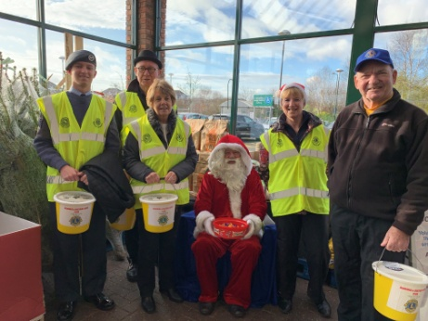
The Squadron has been busy recently supporting Santa and Aldridge and District Lyons Club to raise funds for charity. Earlier this year they proudly presented an evening of music by the Birmingham Canoldir Male Choir at Aldridge Social Club.
All proceeds went to the charities James Brindley Foundation and Lions Brain Tumour Research.
‘We raised over £1100 for these worthy causes,” said Mike Barker, Fundraising Chairman. ‘This is the most money that we’ve ever raised before from a single event. And we’ve done a few! We used to run events in the village but this event eclipsed them all. I want to thank local people for their generosity in supporting us and these charities.’
Mike believes volunteering your time not only helps those in need but can give you a sense of pride and accomplishment.
‘Where there is a need there is a Lion,’ Mike said. ‘Every penny raised helps those who are less fortunate.’

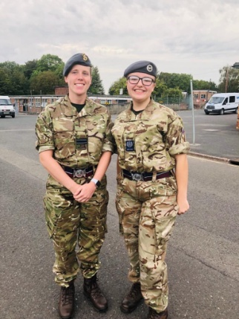
NCO’s Corner

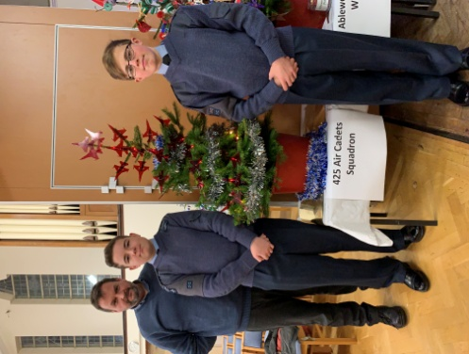

NCO Corner:

Our NCO team consists of:

CWO Mansell
FS Mistry
Sgt Curtis
Sgt Holden
Sgt Smith
Cpl Aulton
Cpl Blakemore
Cpl Kitchen
Cpl Middleton
Cpl E Tapper
Cpl B Tapper

Each week we strive to improve the standards around squadron in regards to discipline, uniform and progression. At 425 we pride ourselves in our ability to provide our Cadets and NCOs with a wide variety of opportunities to become the best version of themselves. Recently, we have launched the new Flight Systems which actively helps us to encourage enthusiasm and foster positivity all of our cadets. This enables the NCO team to effectively mentor within their given flights which ultimately means there’s a constant support system. With the addition of new Cpls we can now begin to train and develop them into knowledgable, integral and approachable individuals who have a natural ability in leadership and the safeguarding of others. Over the next few months we aim to begin preparing for Wing Field Day which means preparing our competition entries in a multitude of categories. Having an experienced NCO in charge of this will help our staff complete admin whilst also building the NCOs confidence within leadership.

Christmas Tree Appeal
The Squadron had Christmas decorations in the style of the RAF Aerobatic Team, the Red Arrows, which is one of the world’s premier aerobatic display teams. The Red Arrows represent the speed, agility and precision of the Royal Air Force and act as ambassadors for the United Kingdom at home and overseas and promote the best of British.

‘I love Christmas,’ said Cadet Chilton, ‘and decorating trees! Our Red Arrows Christmas Tree is something fun to do as part of the community. I think the tree gets the message of the Red Arrows across and us as Air Cadets.’

The Red Arrows fly BAE Systems` Hawk T1, which is powered by a Rolls-Royce engine. The technical expertise of their pilots is crucial to their team`s success. With their trademark Diamond Nine shape and combination of close formations and precision flying, the Red Arrows have been displaying since 1965.

The Red Arrow decorations for the tree were made by Paul Bates, a Civilian Instructor at 425 (Aldridge) Squadron. Paul supports the young people of Aldridge as a volunteer including projects leading to the Duke of Edinburgh`s Awards. Paul is passionate about supporting the local community.

‘The Air Cadets is part of the community,” he said. ‘We have a tree amongst 60 other groups and companies in evidence of that role. The Red Arrows is synonymous with the Royal Air Force and illustrates the teamwork of the Royal Air Force and Air Cadets.’

An important part of being a member of the RAF Air Cadets is supporting local community events and causes. In Aldridge it is something they are really good at for the best outcome for the village residents.

‘I took part in the Christmas Tree Festival,’ said Cadet Follows, ‘to show the community and the people of Aldridge that coming together for the festive season can be a happy and exciting time for family and friends. A lot of work, time and effort have been put into the Christmas Tree Festival. I am proud to say we made these Red Arrow decorations and we are 425 Squadron.’

CIV COM CORNER UPDATE
An update from our hardworking Civilian Committee who also helps us all of the financial management and legal elements of the Squadron:
2019 has been a terrific year for the Civilian Committee. The year has been highly successful, raising just under £2000. Our Dining Inn event was very popular, with 80 guests, filling the room up to its highest capacity. Our last and biggest fundraiser was the Christmas Eve bag pack which raised 425 a total of £1460 in just a few hours. Thank you to all who helped. Any donation helps.

